**LAB PROJECT REPORT NO. 1: CONTROLS & MODELING OF A DC MOTOR**

Students:

Gianfranco Fanton Aita (ID: 26233570)

Estuardo Joel Higueros Reyes (ID: 26768792)

Instructor: Dr. Nasrallah, Danielle

Lab. Instructor: Mr. Hamid Ebrahimi Orimi

Course Number: MECH 473

Course Name: Control System Design

Section M

Due: Friday, October 28th, 2016

Concordia University

* **ABSTRACT**

*The purpose of the laboratory project consists of the design and implementation of a controller using Matlab/Simulink, and a programming language such as C. The set up consists of a DC motor which will simultaneously drive an inertial load, as well as a DC generator. The DC motor is to be controlled using a computer, and the hardware provided is the Quanser Q4 board. The following report is separated in two parts. The first part of this paper discusses sensors utilized, and their connections; their implementation in this project is also covered. Detailed explanations for the functions of the power supply, the operational amplifier, the DAQ Q4 card, the motors, and the oscilloscope will also be provided. Following this, Simulink models, and their results are outlined for different cases, as were covered in the first 2 sessions of the project. For the second half of this report, derivations and analysis of the DC motor are emphasized. Indeed, the DC motor differential equations for the electronic and mechanical parts of the system are derived and explained. Moreover the latter are used to derive the electro-mechanical system of the brushed DC motor. Also, the block diagrams for these systems are drawn to portray the DC motor’s behavior. Furthermore, the open-loop and unit closed-loop negative feedback systems for when the inductance constant is negligible and for when it is not, is analyzed. In fact, after obtaining the Simulink block diagram for the mentioned systems, the angular position and velocity to a step input (time response) is to be obtained. Finally, these graphs and models are to ultimately illustrate the behavior of the DC motor under distinct circumstances.*

* **CONTENTS**
* **LIST OF CONTENTS**

1. Introduction……………………………………………………………………….………..P. 5
2. Sensors & Connections………………………………………………………….……..P. 5
3. Power Supply & Oh-Amp…………………….………………………...………..…….P. 7
4. Motors…………………………………………………………………………….…....P. 8
5. Oscilloscope…………………………………………………………………………....P. 9
6. DAQ Card Structure……………………………………………………………..……P. 10
7. Simulink QuaRC & Calibration…………………………………………………………..P. 12
8. Simulink Model……………………………………………………………………….P. 12
9. Sensor Connections Analysis………………………………………………………....P. 13
10. Motor Dynamical Modeling…………………………………………………………....…P. 15
11. Derivations & Analysis………………………………………………………………..P. 15
12. For Electronic Model…………………………………...…………………………......P. 15
13. For Mechanical Model………………………………………………………………...P. 16
14. For Electro-Mechanical Model………………………………………………………..P. 17
15. Lab No. 3 Questions…………………………………………………………………..P. 23
16. Question No. 1………………………………………………………………………...P. 23
17. Question No. 2………………………………………………………………………...P. 24
18. Question No. 3………………………………………………………………………...P. 25
19. Question No. 4………………………………………………………………………...P. 26
    * + (a) For [TF]OL1…………………………………………………………………….P. 28
      + (b) For [TF]OL2…………………………………………………………………….P. 31
20. Question No. 5………………………………………………………………………...P. 34
    * + (a) For [TF]UCL1…………………………………………………………………...P. 36
      + (b) For [TF]UCL2…………………………………………………………………...P. 39
21. References…………………………………………………………………………………P. 42

* **LIST OF FIGURES**

1. **SECTION ONE**………………………………………………………………..……P. 5
2. Fig. 1.1: Tachometer………………………………………………………………..P. 5
3. Fig. 1.2: Encoder Functionality Diagram…………………………………………...P. 6
4. Fig. 1.3: Amplifier…………………………………………………………………..P. 8
5. Fig. 1.4: Brushed DC Motor………………………………………………………...P. 9
6. Fig 1.5: Oscilloscope Display……………………………………………………...P. 10
7. **SECTION TWO**…………………………………………………………………..P. 12
8. Fig. 2.1: Simplified Motor Control System………………………………………...P. 12
9. Fig. 2.2: Simplified System Response for a Step Input…………………………….P. 13
10. Fig. 2.3: Q4 & Sensors Simulink Model…………………………………………...P. 14
11. **SECTION THREE**……………………………………………………………….P. 15
12. Fig. 3.1: Electronic Model………………………………………………………....P. 16
13. Fig. 3.2: Mechanical Model………………………………………………………..P. 17
14. Fig. 3.3(a): Block Diagram with a Nested Loop…………………………………...P. 20
15. Fig. 3.3(b): Block Diagram with a Single Loop……………………………………P. 21
16. Fig. 3.3(c): Block Diagram, when *La* << 1…………………………………………P. 22
17. Fig. 3.4.1(a): Simulink Block Diagram……………………………………………P. 28
18. Fig. 3.4.1(b): Angular Position Response to a Step Input………………………….P. 29
19. Fig. 3.4.1(c): Angular Velocity Response to a Step Input………………………….P. 30
20. Fig. 3.4.2(a): Simulink Block Diagram……………………………………………P. 31
21. Fig. 3.4.2(b): Angular Position Response to a Step Input………………………….P. 32
22. Fig. 3.4.2(c): Angular Velocity Response to a Step Input………………………….P. 33
23. Fig. 3.5.1(a): Simulink Block Diagram……………………………………………P. 36
24. Fig. 3.5.1(b): Angular Position Response to a Step Input………………………….P. 37
25. Fig. 3.5.1(c): Angular Velocity Response to a Step Input………………………….P. 38
26. Fig. 3.5.2(a): Simulink Block Diagram……………………………………………P. 39
27. Fig. 3.5.2(b): Angular Position Response to a Step Input………………………….P. 40
28. Fig. 3.5.2(c): Angular Velocity Response to a Step Input………………………….P. 41

* **INTRODUCTION**

**(a) Sensors & Connections:**

The sensors involved in this project include a tachometer, an encoder, and a potentiometer. The following lines will dive into the explanation of how each of them work. Let us deal first with the tachometer, which is, in the briefest terms, a device capable of measuring velocity. These devices are designed to produce an analog voltage which is directly proportional to the rotational speed of a shaft, or rotor. This is achieved through the tachometer, which is a basic DC motor that comprises a permanent magnet stator, as well as a coil armature [1]. For better illustration, consider a DC motor with variable voltage. The tachometer is coupled to the DC motor’s shaft, and will consequently be driven by it. The output voltage of the tachometer, which is readable by using a DMM, or an oscilloscope, should be directly proportional to the rotational velocity of the rotor. The velocity can be verified using a separate velocity measuring device such as an infrared tachometer, or a magnetic pickup coil. The following figure illustrates a basic tachometer.

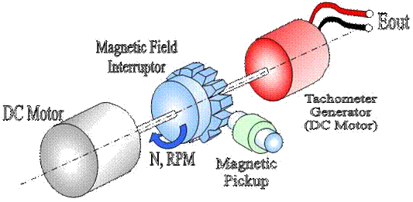

**Fig. 1.1:** Tachometer [2]

Moving on to a different sensor, the following segment of the report will explain the operation of encoders. In fact, it is worth mentioning that there exist different types of encoders. Most often, theses encoders are classified as sensing technology, and output signal. In this case, the experiment makes usage of an incremental output signal encoder. Accordingly, the scope of this report, with respect to encoders, will only encompass output signal encoders. Being able to provide incremental motor position is the purpose of an encoder. Most of these devices are composed of two switch rings which are concentric with respect to one another. The switch rings have contact zones on them; depending on the encoder the design might differ and have pins instead of contact zones, or pins on them. Still, the working principles remain the same. A common terminal is installed, which can rotate with angular velocity. As the common terminal rotates, the terminal encounters the pins located on the switch rings generating square wave signals for each pin. Now, for better illustration, refer to diagram below, which illustrates the basic architecture of an encoder. Take note that the two pins, or contact zones are labelled as A and B. Furthermore, the blue line depicts the rotational common terminal. On the bottom left side of the figure are two graphs illustrating the square wave signals of channels A and B.

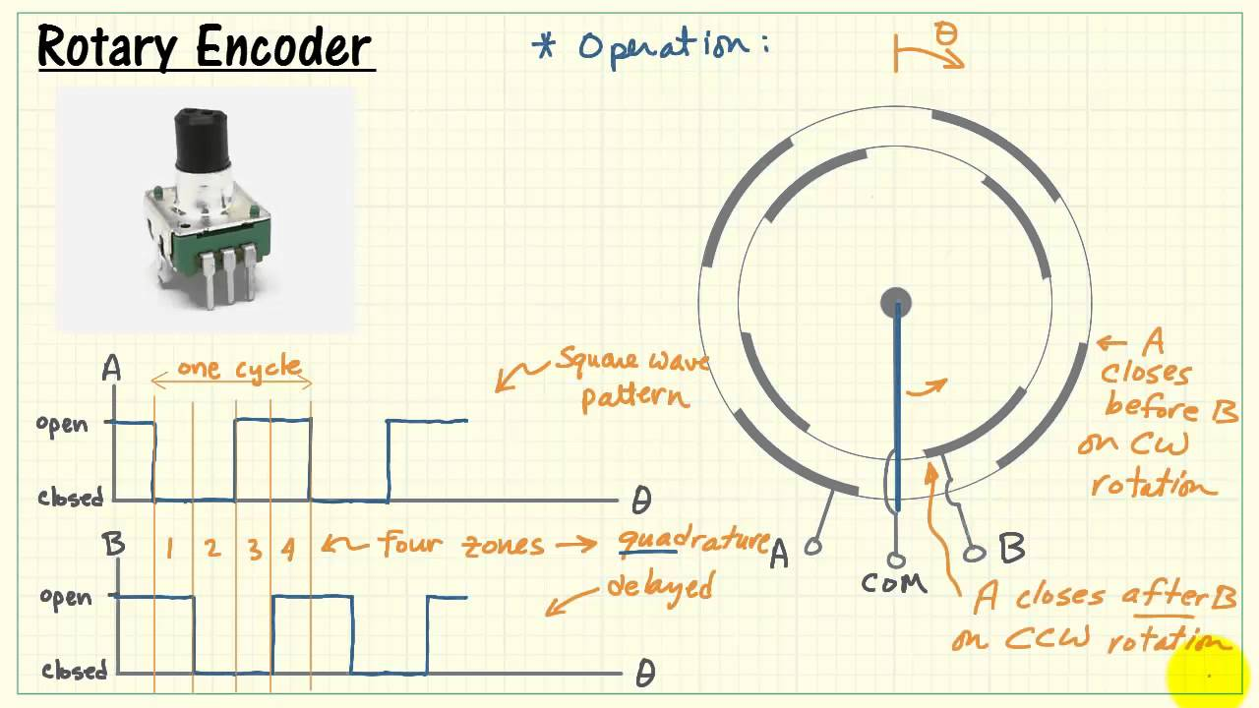

**Fig. 1.2:** Encoder Functionality Diagram [3]

Further analysis of the graph will provide a greater understanding of the function of the encoder. Indeed, an important feature is the lagging phase present in one cycle. The 90 degree out of phase states the direction of rotation. In fact, while signal is dropping to a low state in channel A, channel B is still in a high state. Hence, an encoder will output a certain number of pulses which will correspond to a specific position. In other words, "channels output a specific number of pulses for a unit of shaft motion" [1]. Like an encoder, but different with regards to functionality, a potentiometer uses variable voltage to give a shaft angular position. In the simplest terms, a potentiometer is basically a voltage divider. Certainly, most potentiometers comprise a resistive element connected to two terminals. The driving element is termed an adjustable wiper, which acts as the voltage divider. The three components allow manual adjustment of the variable resistor. The following expression is derived from a voltage divider circuit $V_{out} =V_{source}\frac{R_{2}}{R_{1}+R_{2}}$. In the light of this expression, if the voltage source, and resistance values are known, the desired output voltage can be generated. Now that the workings of each sensor have been covered, the focus will be shifted to the connections and circuits built for this project. To begin with, the encoder is normally powered through its Vcc pin and GND pin. In order to check the signal from channels A and B of the encoder, an oscilloscope is used. Next, to drive the motor, the power module out is put to use. As for the tachometer, connect it to channel 1 of the oscilloscope, and connect the potentiometer to scope channel 2 [1].

**(b) Power Supply & Op-Amp:**

The power supply used for this project is a DC power supply. Even though the name of the power supply is self-explanatory, a basic explanation will be provided so as to understand the specifications of the power supply. As a matter of fact, a DC power supply is capable of providing a constant DC voltage to a load. It is worth mentioning that most DC supplies are powered from an alternate current source. So, one might ask how AC is converted to DC. The conversion is achieved through an inbuilt rectifier. These filters are effective in removing the AC signal (most of it). The DC power supply used for this experiment has three terminals +12V, -12V, and GND. Moreover, the function of an operational amplifier, or op-amp for short, is to provide a high gain. More specifically, the component is fed an input signal, and it outputs the signal with a larger voltage. Hence, the gain of the amplifier is the value multiplied to the voltage. To illustrate what is being explained, the following figure depicts an operational amplifier; note this is a simplified structure of an op-amp.

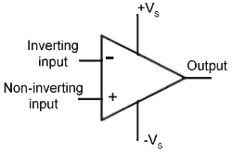

**Fig. 1.3:** Amplifier [4]

The end of the op-amp corresponds to the output voltage. The positive and negative pins correspond to the non-inverting input, and inverting input correspondingly; these are the signal inputs. It is important to know that an operational amplifier needs to be powered, hence the two terminals for power supply. The operational amplifier used in this project comprises "four binding posts" [1]. Depending on the station in the laboratory, the model might differ slightly. Nonetheless, both models have the output, non-inverting input, and inverting input labeled.

**(c) Motors:**

As stated in the project manual, a Pittman Series GM9000 LO-GOG Brush-commutated Gearmotor is used. The operation of a simple DC motor consists of a permanent magnet stator in which in between each pole lies a rotational coil armature. The armature is connected to a power supply via a pair of commutator rings. When current is allowed to flow in the coil, Lorentz law dictates that a magnetic force is generated. This can be easily visualized using the right hand rule (RHR), where the thumb points in the direction of the current, the index in the direction of the magnetic field, and the middle finger is the generated force. Thus, the coil would rotate in the direction of the force vector. In order to have a smooth motion, and avoid irregular motion, DC motors have multiple coils to provide a constant torque whenever polarity switches at commutators. In practice, brushed DC motors are the less expensive type of motors, and provide general good performance. That being said, it is worth mentioning that brushed motors wear out at a faster rate than other types, such as brushless DC motors. This can be attributed to overheating, and sparking of the commutators. Subsequently, the brushless DC motors have a more reliable performance where wear is not of great concern, but since this project does not make use of such motors, this paper will limit itself to the presentation of brushed DC motors. When working with DC motors, and integrating them into a circuit, it is important to take into account the back electromotive force (EMF) generated. Indeed, the EMF can potentially be detrimental to a circuit. The following figure depicts the structure of a basic brushed DC motor. In addition, the latter depicts the inside structure of a basic DC motor. Notice the red and blue elements show the polarity of the permanent magnet stator. A last component in its structure consists of the armature on which the coils are joined. As can be seen, the coils rotate according to the Lorentz law. In that case, the motion will drive the shaft, and generate an angular velocity. Finally, if a DC motor is worked inversely, they basically act as generators.

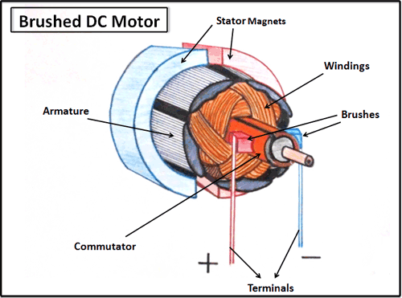

**Fig. 1.4:** Brushed DC motor [5]

**(d) Oscilloscope**

An important apparatus which provides a visual representation of signals is an oscilloscope. Indeed, oscilloscopes plot changes in voltage over time. When powering an oscilloscope, a graphical map is displayed, having volts on the vertical axis, and time on the horizontal axis. Using the appropriate knobs, the scales of the axes can be changed to adjust the measured signals. Digital oscilloscope can measure voltage and frequency, and this is ideal when dealing with digital circuits, and serial communication. When working with digital circuits, logic probes are used for measurement. Interconnections between the different components, and the oscilloscope, can be achieved by using banana pugs. The oscilloscope in the laboratory can be connected to an MS Excel. If connected to a computer, a display will appear. Following this, the oscilloscope is connected in Excel by clicking Add-ins. The following figure is the display of the oscilloscope.



**Fig. 1.5:** Oscilloscope Display [6]

In proper order, the first symbol displays the acquisition mode. The second icon is the trigger status. Icons numbers 3 and 5 are markers for position and level, respectively. The forth icon displays the difference between the origin and horizontal trigger positon [6]. The seventh icon displays the voltage level. Next to the seventh icon is the trigger type button, which is followed by the trigger source button. Lastly, the 10th icon displays the time base, while the eleventh icon is simply the vertical scale factors (icons number 12 and 13 are reference markers).

**(e) DAQ Card Structure**

The board used in this experiment is a Q4 DAQ board. An advantage in using this board is that analog and digital sensors can easily be connected to it. This Quanser board is an useful module for real time control. Indeed, the board is compatible with Simulink. As a result, this allows models to be ran. There are many features involved in this particular board. Consequently, this paper will only emphasize on the components relevant to the project. Indeed, the Q4 board, which supports analog input, has four 14-bit analog inputs [7]. The DAQ board has an integrated analog to digital converter which can simultaneously operate four channels [1]. Similarly, the board has four 14-bit analog outputs. The analog output has a range of “±10V, ±5V or 0-10V” [7]. Additionally, the Quanser Q4 board supports 16 digital I/O channels which can be programmed as inputs or outputs. Also, the Quanser Q4 board has an integrated "12-bit digital-to-analog converter" [1]. Furthermore, the board has very interesting features, which include the encoder inputs, and the PWM outputs. The board "supports four quadrature encoder inputs" [7] having a 24-bit count. Lastly, the Q4 has two PWM output lines.

* **SIMULINK QuaRC & CALIBRATION**

**(a) Simulink Model**

From the 2nd session of the project a simple motor control system was modeled as:

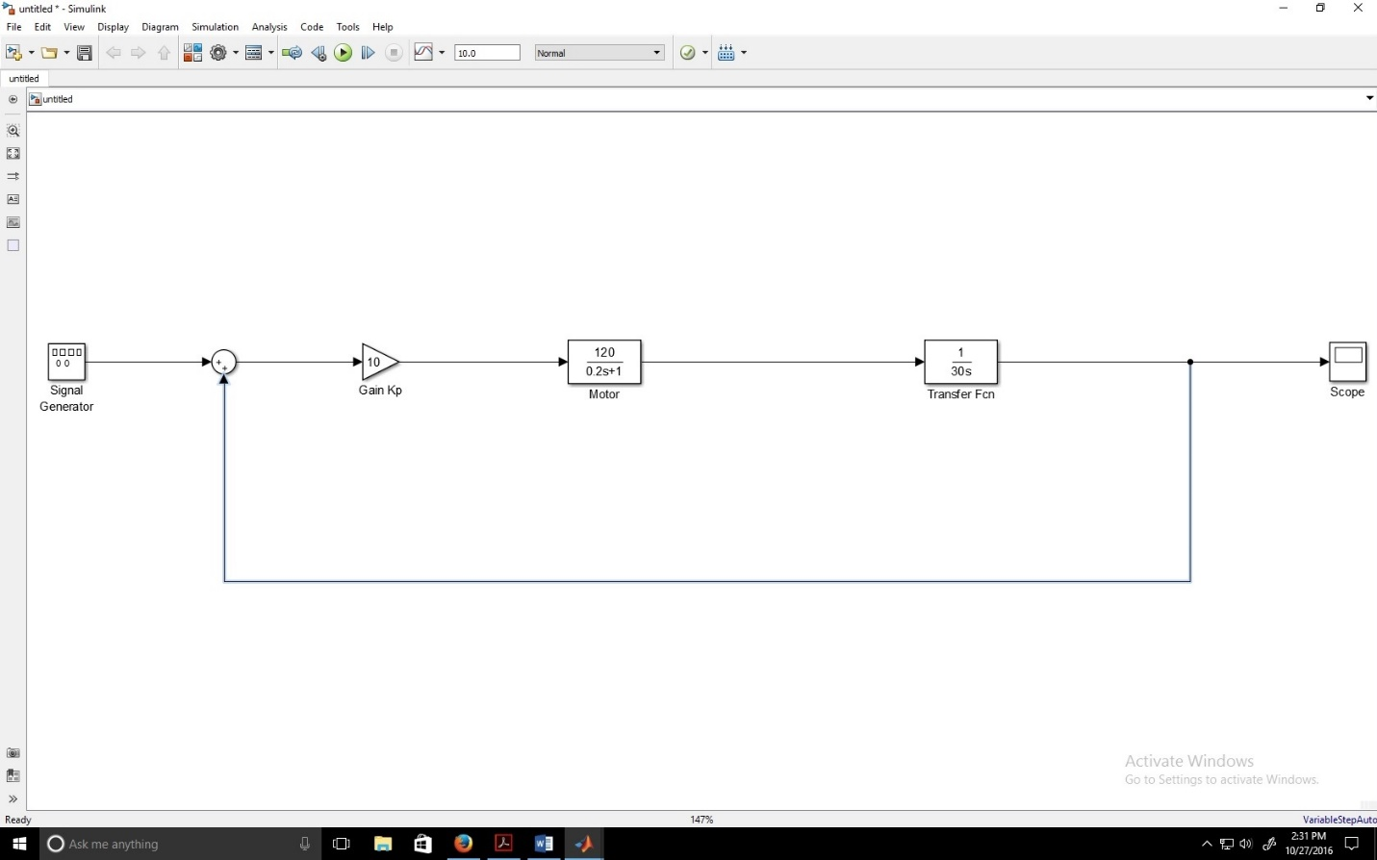

**Fig. 2.1:** Simplified Motor Control System

Notice that a square wave was selected in the parameters of the signal generator. More specifically, a unit input square wave. Once the Simulink file is compiled the following output is displayed inside the scope:

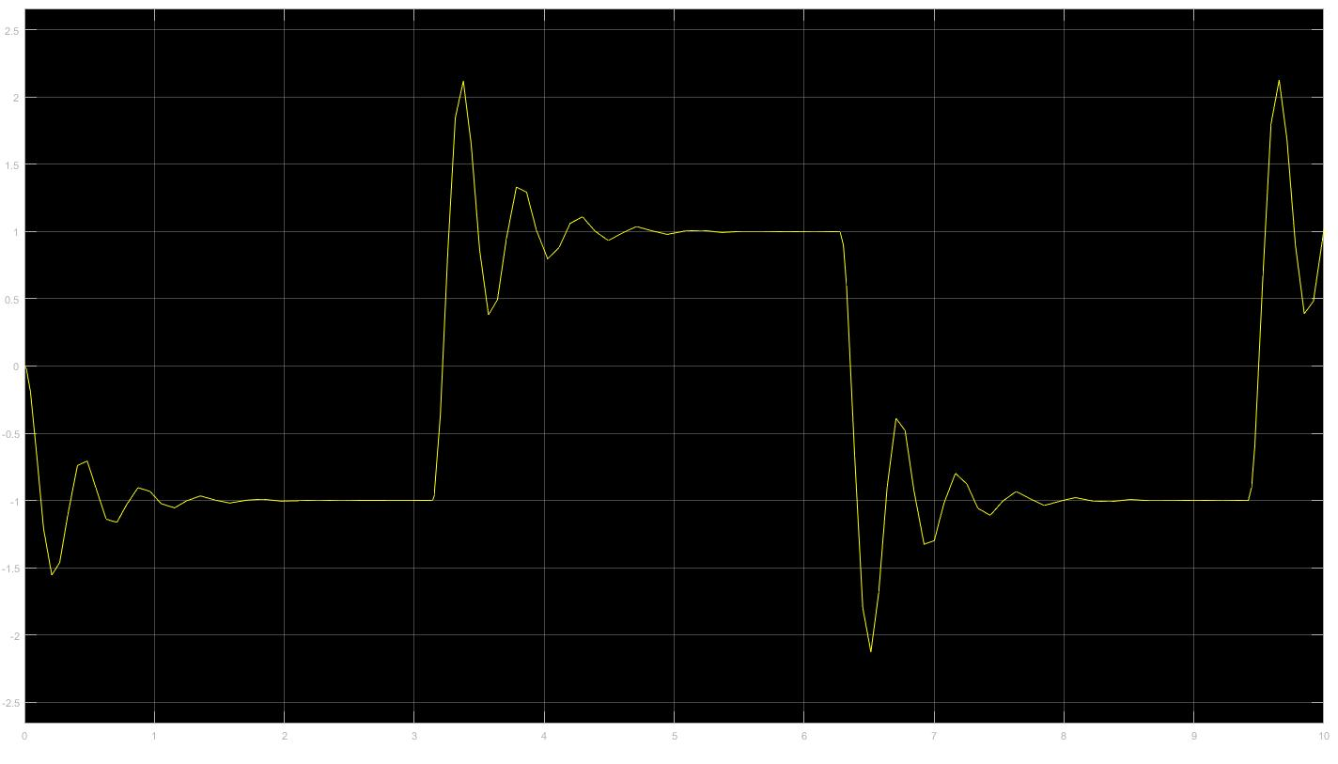

**Fig. 2.2:** Simplified System Response for a Step Input

**(b) Sensor Connections Analysis**

The next line following lines will explain how these sensors were involved in the project. In the 2nd session, a potentiometer was manually turned by providing a voltage to the slider gain that is greater than 1; notice that a value of 1 is simply a unity gain. The resulting output was displayed on the encoder pot once a gain was applied. It was seen through the pot that the voltage range was between 0 to 5 volts. As a result, the corresponding correcting factor was of $K= \frac{360}{5}$; a pot can be added to verify correction. As for the tachometer, a specific voltage was provided, in this case 3 volts, and its corresponding RPM was recorded as 180 rpm. The computed scaling factor came out to be $K= \frac{180}{3}$. Next, for the third case, the encoder was manually turned. However, before that, a marker was used to draw a reference line on top of the encoder. Another line, aligned and parallel to the reference one is drawn on the encoder. Then, Simulink was compiled in order to see the values in action. Next, the shaft was rotated by one complete revolution (360 degrees) until the two lines were once again aligned. This displayed a voltage equal to 6.68 e+04, or 6680, and then its gain is given by $K= \frac{6680}{360}$. From this, you can know the proper increments. To conclude, the purpose of this experiment was to understand analog to digital scaling. The following figures consist of the Simulink models for all three cases. Notice however, that in this picture the Q4 board is absent because this was saved, and then re-opened on a different computer, not connected to the board; Therefore, the Q4 board is absent in this particular screenshot.

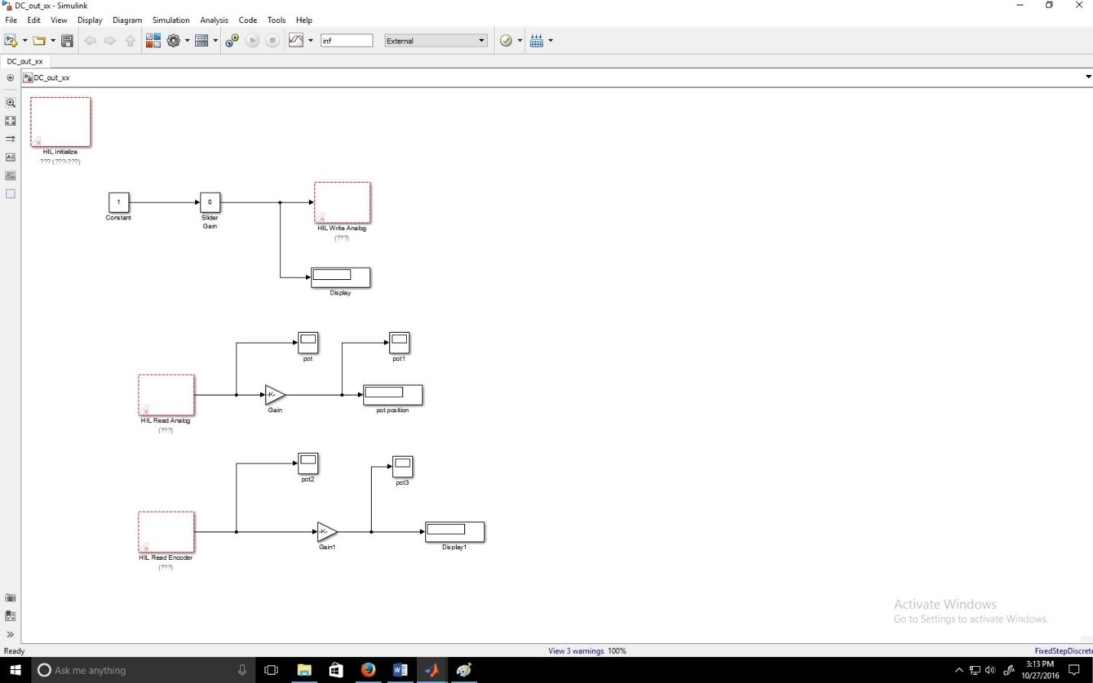

**Fig. 2.3:** Q4 & Sensors Simulink model

* **MOTOR DYNAMICAL MODELING**

1. **DERIVATIONS & ANALYSIS**

**(a)** For Electronic Model

* Deriving the Transfer Function for the Electronic System of the Motor:

$$\sum{V=V_{a}}$$

$$L_{a}\left(\frac{di}{dt}\right)+ R_{a}i+ V_{b}=V_{a}$$

$$L_{a}\left(\frac{di}{dt}\right)+ R_{a}i+ K_{e}ω=V_{a}$$

$$L\left[L_{a}\left(\frac{di}{dt}\right)+ R_{a}i+ K_{e}ω\right]=L\left.\left[V_{a}\right]\right.$$

$$L_{a}si(s)+ R_{a}i(s)+ K_{e}ω(s)=\left.V_{a}(s)\right.$$

$$i\left(s\right)\left(L_{a}s+ R_{a}\right)+ K_{e}ω\left(s\right)=\left.V_{a}\left(s\right)\right.$$

$$i\left(s\right)\left(L_{a}s+ R_{a}\right)=\left.V_{a}\left(s\right)- K_{e}ω\left(s\right)\right.$$

$$\left(\frac{i\left(s\right)}{\left(V_{a}\left(s\right)- K_{e}ω\left(s\right)\right)}\right)=\left(\frac{1}{\left(L_{a}s+ R_{a}\right)}\right) [1]$$

In fact, the armature voltage *Va*, and the back-EMF (back electromotive force) voltage *Vb*, are the inputs of the electronic part of the overall system. In that case, *Vb= Keω*, which consists of the electro-mechanical coupling for this part of the system. Subsequently, *Ke* is the back-EMF constant, and *ω* depicts the angular velocity variable. Also, *La* is the inductance constant and *Ra* is the resistance constant. Finally, the output of the system is the current variable *i*, flowing through the armature circuit.

* Block Diagram for the System:



**Fig. 3.1[1]**: Electronic Block Diagram

**(b)** For Mechanical Model

* Deriving the Transfer Function for the Mechanical System of the Motor:

$$\sum{J_{m}\dot{ω}=T_{m}}$$

$$J_{m}\left(\frac{d}{dt}\left(\frac{dθ}{dt}\right)\right)+ f\left(\frac{dθ}{dt}\right)+ T_{L}=T_{m}$$

$$J_{m}\left(\frac{d}{dt}\left(\frac{dθ}{dt}\right)\right)+ f\left(\frac{dθ}{dt}\right)+ T_{L}=K_{t}i$$

$$L\left[J_{m}\left(\frac{d}{dt}\left(\frac{dθ}{dt}\right)\right)+ f\left(\frac{dθ}{dt}\right)+ T_{L}\right]=L\left[K_{t}i\right]$$

$${J_{m}s}^{2}θ(s)+ sθ(s)f+ T_{L}(s)=K_{t}i(s)$$

$${J_{m}s}^{2}θ\left(s\right)+ sθ\left(s\right)f=K_{t}i\left(s\right)- T_{L}(s)$$

$$θ\left(s\right)\left({J_{m}s}^{2}+ sf\right)=K_{t}i\left(s\right)- T_{L}(s)$$

$$ω\left(s\right)\left(J_{m}s+ f\right)=K_{t}i\left(s\right)- T_{L}(s)$$

$$\left(\frac{ω\left(s\right)}{K_{t}i\left(s\right)- T_{L}(s)}\right)=\left(\frac{1}{\left(J_{m}s+ f\right)}\right) [2]$$

The mechanical differential equation of the motor has a 2 inputs. These consist of the torques *Tm* and *TL*. In fact, the torque *Tm* depicts the torque implemented by the motor, while the torque *TL* is composed of the load torque (a disturbance in the system). Moreover, *Tm = Kti*, since the latter consists of the electro-mechanical coupling in the mechanical part of the overall system. Indeed, *Kt* is the torque constant inflicted by the motor, while *i* is the current variable in the armature circuit. Also, the constant *Jm* represents the total inertial load of the motor, while the constant f consists of the damping in the motor system. Finally, the output of the system is the angular velocity variable, *ω*.

* Block Diagram for the System:



**Fig 3.2 [1]**: Mechanical Block Diagram

Note that in this block diagram, the torque disturbance *TL* has been set to zero.

**(c)** For Electro-Mechanical Model

* Deriving the Transfer Function for the Overall Electro-Mechanical System:

***(i)*** Solving for *i(s)*, in equation [1]:

$$\left(\frac{i\left(s\right)}{\left(V_{a}\left(s\right)- K_{e}ω\left(s\right)\right)}\right)=\left(\frac{1}{\left(L_{a}s+ R_{a}\right)}\right)$$

$$i(s)=\left(\frac{\left(V_{a}\left(s\right)- K_{e}ω\left(s\right)\right)}{\left(L_{a}s+ R_{a}\right)}\right)$$

***(ii)*** Solving for *ω(s)*, in equation [2]:

$$\left(\frac{ω\left(s\right)}{K_{t}i\left(s\right)- T_{L}(s)}\right)=\left(\frac{1}{\left(J_{m}s+ f\right)}\right)$$

$$ω(s)=\left(\frac{\left(K_{t}i\left(s\right)- T_{L}(s)\right)}{\left(J_{m}s+ f\right)}\right)$$

***(iii)*** Plugging in equation for *i(s)* in equation for *ω(s)*:

$$ω(s)=\left(\frac{\left(K_{t}\left(\frac{\left(V_{a}\left(s\right)- K_{e}ω\left(s\right)\right)}{\left(L_{a}s+ R_{a}\right)}\right)- T_{L}(s)\right)}{\left(J_{m}s+ f\right)}\right)$$

$$ω(s)=\left(\frac{\left(\frac{K_{t}\left(V_{a}\left(s\right)- K_{e}ω\left(s\right)\right)- T_{L}(s)\left(L_{a}s+ R_{a}\right)}{\left(L_{a}s+ R_{a}\right)}\right)}{\left(J_{m}s+ f\right)}\right)$$

$$ω(s)=\left(\left(\frac{K_{t}\left(V_{a}\left(s\right)- K_{e}ω\left(s\right)\right)- T_{L}(s)\left(L_{a}s+ R_{a}\right)}{\left(L_{a}s+ R_{a}\right)}\right)\left(\frac{1}{\left(J_{m}s+ f\right)}\right)\right)$$

$$ω(s)=\left(\left(\frac{K_{t}\left(V_{a}\left(s\right)- K_{e}ω\left(s\right)\right)- T_{L}(s)\left(L_{a}s+ R_{a}\right)}{\left(L_{a}s+ R_{a}\right)\left(J_{m}s+ f\right)}\right)\right)$$

$$\left(L_{a}s+ R_{a}\right)\left(J_{m}s+ f\right)ω(s)= K_{t}\left(V_{a}\left(s\right)- K_{e}ω\left(s\right)\right)- T_{L}(s)\left(L_{a}s+ R_{a}\right)$$

$$\left(L_{a}s+ R_{a}\right)\left(J_{m}s+ f\right)ω\left(s\right) + K_{t}K_{e}ω\left(s\right)= K_{t}V_{a}\left(s\right)- T_{L}(s)\left(L_{a}s+ R_{a}\right)$$

$$\left(\left(L_{a}s+ R_{a}\right)\left(J_{m}s+ f\right)+K_{t}K_{e}\right)ω\left(s\right) = K_{t}V_{a}\left(s\right)- T_{L}(s)\left(L_{a}s+ R_{a}\right)$$

***(iv)*** Such that the disturbance inflicted by *TL(s)* = JMsω(s) (Torque of Disk):

$$\left(\left(L_{a}s+ R_{a}\right)\left(J_{m}s+ f\right)+K_{t}K_{e}\right)ω\left(s\right) = K_{t}V_{a}\left(s\right)- J_{M}sω(s)\left(L_{a}s+ R_{a}\right)$$

$$\left(\left(L_{a}s+ R_{a}\right)\left(J_{m}s+ f\right)+K_{t}K_{e}{+ J}_{M}s\left(L_{a}s+ R_{a}\right)\right)ω\left(s\right) = K_{t}V_{a}\left(s\right)$$

***(v)*** Then, the closed-loop (CL) transfer function for the DC-Brushed Motor is:

For angular speed, ω:

$${\left(\frac{ω\left(s\right)}{V_{a}\left(s\right)}\right)}_{CL} =\left(\frac{K_{t}}{\left(L_{a}s+ R_{a}\right)\left(J_{m}s+ f\right)+K_{t}K_{e}{+ J}_{M}s\left(L_{a}s+ R_{a}\right)}\right)= \left(\frac{K_{t}}{{{(J}_{m}+ J_{M})L}_{a}s^{2}+\left(L_{a}f+{{(J}_{m}+ J_{M})R}_{a}\right)s+ fR_{a}+K_{t}K_{e}}\right)$$

Or, alternatively, for angular position, θ:

$${\left(\frac{θ\left(s\right)}{V_{a}\left(s\right)}\right)}_{CL} =\left(\frac{K_{t}}{s\left(\left(L_{a}s+ R_{a}\right)\left(J_{m}s+ f\right)+K_{t}K_{e}{+ J}_{M}s\left(L_{a}s+ R_{a}\right)\right)}\right)=\left(\frac{K_{t}}{{{(J}_{m}+ J_{M})L}_{a}s^{3}+\left(L_{a}f+{{(J}_{m}+ J_{M})R}_{a}\right)s^{2}+\left(fR_{a}+K_{t}K_{e}\right)s}\right)$$

***(vi)*** Finally, setting the inductance (*La*) to zero, since *La*<< 1:

$${\left(\frac{ω\left(s\right)}{V_{a}\left(s\right)}\right)}_{CL}= \left(\frac{K_{t}}{{{(J}_{m}+ J_{M})R}_{a}s+ fR_{a}+K_{t}K_{e}}\right)$$

$${\left(\frac{θ\left(s\right)}{V_{a}\left(s\right)}\right)}_{CL}= \left(\frac{K_{t}}{{{(J}_{m}+ J_{M})R}_{a}s^{2}+\left(fR_{a}+K_{t}K_{e}\right)s}\right)$$

* Such that *Jm* is the inertial load of the motor and *JM* is the inertial load of the disk.
* Negative Feedback System for Electro-Mechanical DC Motor:

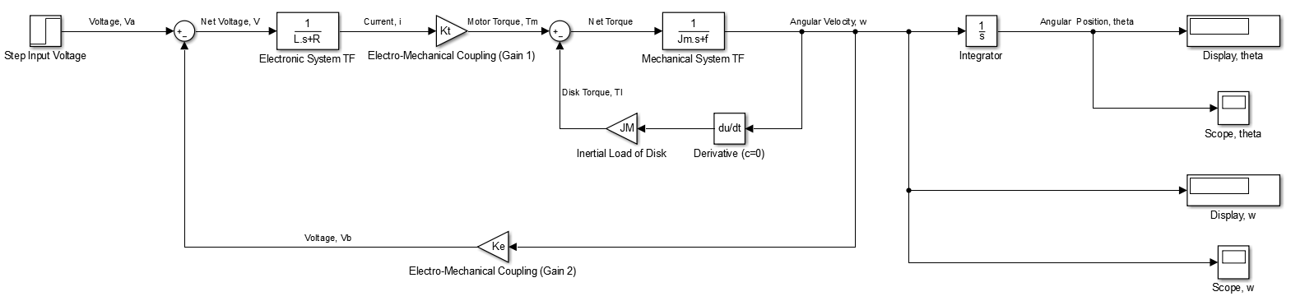

**Fig. 3.3 (a):** Block Diagram with a Nested Loop

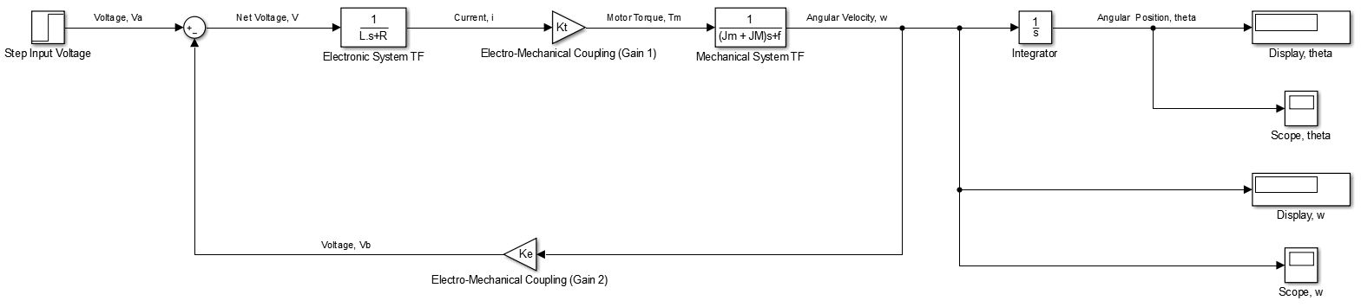

**Fig. 3.3 (b):** Block Diagram with Single Loop

* Note that the systems described in the two figures above are equivalent. The second system (Fig. 3.3(b)) is the result of reducing the first system’s (Fig. 3.3(a)) inner negative feedback loop.
* If the inductance constant is very small, the Negative Feedback System Becomes:

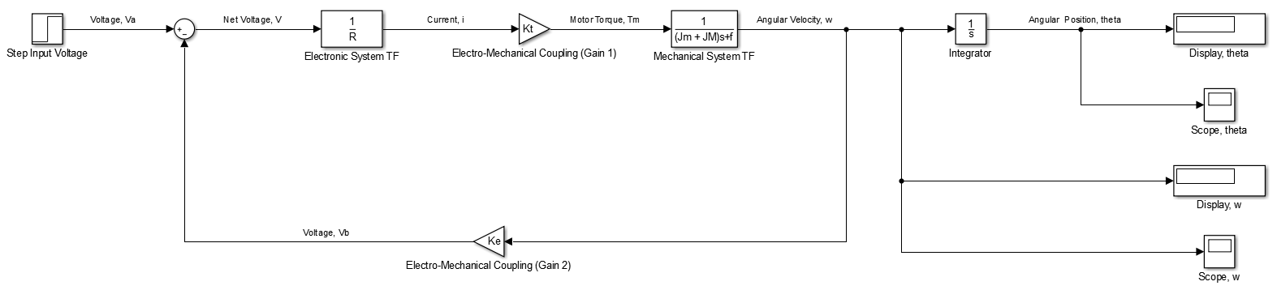

**Fig. 3.3 (c):** Block Diagram when La<< 1

1. **LAB NO. 3 QUESTIONS**

**1.** Derive the motor open-loop (OL) transfer functions for:

$$\frac{ω\left(s\right)}{V_{a}(s)} and \frac{θ(s)}{V_{a}(s)}$$

Noting the derivations and block diagrams in the previous section, and considering that only the inertial load for the motor is considered, the open-loop transfer function for the overall system is:

$${\left(\frac{ω\left(s\right)}{V_{a}\left(s\right)}\right)}_{OL} =K_{1}G_{1}(s)G_{2}(s)$$

Such that,

$$K_{1}=K_{t}$$

$$G_{1}\left(s\right)=\left(\frac{i\left(s\right)}{\left(V_{a}\left(s\right)- K_{e}ω\left(s\right)\right)}\right)=\left(\frac{1}{L_{a}s+ R_{a}}\right)$$

$$G_{2}\left(s\right)=\left(\frac{ω\left(s\right)}{K_{t}i\left(s\right)- T_{L}(s)}\right)=\left(\frac{1}{J_{m}s+ f}\right)$$

Where, Jm is the inertial load of the motor.

Then,

$${\left(\frac{ω\left(s\right)}{V_{a}\left(s\right)}\right)}_{OL} =K_{t}\left(\frac{1}{\left(L_{a}s+ R_{a}\right)}\right)\left(\frac{1}{\left(J_{m}s+ f\right)}\right)$$

$${\left(\frac{ω\left(s\right)}{V_{a}\left(s\right)}\right)}_{OL} =\left(\frac{K_{t}}{\left(L_{a}s+ R_{a}\right)\left(J_{m}s+ f\right)}\right)=\left(\frac{K_{t}}{{(L}_{a}J_{m})s^{2}+ \left(L_{a}f+{R_{a}J}_{m}\right)s+ R_{a}f}\right)$$

$${\left(\frac{θ\left(s\right)}{V_{a}\left(s\right)}\right)}_{OL} =\left(\frac{K_{t}}{s\left(L_{a}s+ R_{a}\right)\left(J_{m}s+ f\right)}\right)=\left(\frac{K_{t}}{{(L}_{a}J_{m})s^{3}+ \left(L_{a}f+{R_{a}J}_{m}\right)s^{2}+ \left(R_{a}f\right)s}\right)$$

Since it is known that ***La<< 1***, then the inductance variable will be approaching zero. In that case, ***La*** is negligible and the above equations can be approximated to:

$${\left(\frac{ω\left(s\right)}{V_{a}\left(s\right)}\right)}_{OL} =\left(\frac{K_{t}}{{R_{a}J}_{m}s+ R_{a}f}\right)$$

$${\left(\frac{θ\left(s\right)}{V_{a}\left(s\right)}\right)}_{OL} =\left(\frac{K_{t}}{{R_{a}J}_{m}s^{2}+ R_{a}fs}\right)$$

**2.** Consider the inertial disk as a load, and derive the open-loop (OL) transfer functions for:

$$\frac{ω\left(s\right)}{V_{a}(s)} and \frac{θ(s)}{V_{a}(s)}$$

Noting the derivations and block diagrams in the previous section, and considering that both the inertial loads for the motor and the disk are to be considered, the open-loop transfer function for the overall system is:

$${\left(\frac{ω\left(s\right)}{V_{a}\left(s\right)}\right)}_{OL} =K_{1}G_{1}(s)G_{2}(s)$$

Such that,

$$K_{1}=K_{t}$$

$$G_{1}\left(s\right)=\left(\frac{i\left(s\right)}{V_{a}\left(s\right)- K_{e}ω\left(s\right)}\right)=\left(\frac{1}{L_{a}s+ R_{a}}\right)$$

$$G_{2}\left(s\right)=\left(\frac{ω\left(s\right)}{K_{t}i\left(s\right)- T_{L}(s)}\right)=\left(\frac{1}{{(J}_{m}+ J_{M})s+ f}\right)$$

Where, Jm is the inertial load of the motor, and JM is the inertial load of the disk.

Then,

$${\left(\frac{ω\left(s\right)}{V_{a}\left(s\right)}\right)}_{OL} =K_{t}\left(\frac{1}{\left(L_{a}s+ R_{a}\right)}\right)\left(\frac{1}{\left({(J}_{m}+ J_{M})s+ f\right)}\right)$$

$${\left(\frac{ω\left(s\right)}{V_{a}\left(s\right)}\right)}_{OL} =\left(\frac{K_{t}}{\left(L_{a}s+ R_{a}\right)\left({(J}_{m}+ J_{M})s+ f\right)}\right)=\left(\frac{K_{t}}{L_{a}\left(J_{m}+ J_{M}\right)s^{2}+ \left(L_{a}f+{R_{a}(J}_{m}+ J_{M})\right)s+ R_{a}f}\right)$$

$${\left(\frac{θ\left(s\right)}{V_{a}\left(s\right)}\right)}_{OL} =\left(\frac{K_{t}}{s\left(L_{a}s+ R_{a}\right)\left({(J}_{m}+ J_{M})s+ f\right)}\right)= \left(\frac{K_{t}}{L_{a}\left(J_{m}+ J_{M}\right)s^{3}+ \left(L_{a}f+{R_{a}(J}_{m}+ J_{M})\right)s^{2}+ \left(R_{a}f\right)s}\right)$$

Since it is known that ***La<< 1***, then the inductance variable will be approaching zero. In that case, ***La*** is negligible and the above equations can be approximated to:

$${\left(\frac{ω\left(s\right)}{V_{a}\left(s\right)}\right)}_{OL} =\left(\frac{K_{t}}{{R_{a}(J}_{m}+ J_{M})s+ R_{a}f}\right)$$

$${\left(\frac{θ\left(s\right)}{V_{a}\left(s\right)}\right)}_{OL} =\left(\frac{K_{t}}{{R_{a}(J}_{m}+ J_{M})s^{2}+ R_{a}fs}\right)$$

**3.** Can the electrical time constant be omitted? Explain why?

For the purposes of the electro-mechanical system presented above, the electrical time constant of the electrical system consists of the coefficient of the 1st power of 's' of its transfer function, such that its 0th power of 's' is 1.

In that case,

$${TF\left(s\right)}_{Elec. Syst. }=\left(\frac{i\left(s\right)}{V_{a}\left(s\right)- K_{e}ω\left(s\right)}\right)=\left(\frac{1}{L_{a}s+ R_{a}}\right)$$

Such that,

$$\left(\frac{1}{P\left(τs+ 1\right)}\right)=\left(\frac{1}{R_{a}\left(\left(L_{a}/R_{a}\right)s+ 1\right)}\right)$$

Where:

$$P= R_{a} and τ= L_{a}/R_{a}$$

The time constant of the electric system, *τ*, consists of the division of the inductance variable *La* over the resistance variable *Ra*. Since it is known that the inductance variable is significantly small, then it is acceptable to assume *La = 0* (approximately)*.* In that case, the time constant will approach a value of zero. Therefore, the time constant can be omitted, since its value will result in a quantity so small that it is technically negligible.

**4.** Use Simulink to get a step response for the open-loop (OL) modeling, with inertial load.

For open-loop transfer function with inertial load:

$${{\left(a\right) \left[TF\right]}_{{OL}_{1}}=\left(\frac{ω\left(s\right)}{V_{a}\left(s\right)}\right)}_{OL}=\left(\frac{K_{t}}{\left(L_{a}s+ R_{a}\right)\left({(J}_{m}+ J_{M})s+ f\right)}\right)= \left(\frac{K_{t}}{L_{a}\left(J_{m}+ J_{M}\right)s^{2}+ \left(L_{a}f+{R_{a}(J}_{m}+ J_{M})\right)s+ R_{a}f}\right)$$

For reduced (*La*<< 1) open-loop transfer function with inertial load:

$${{\left(b\right) \left[TF\right]}_{{OL}_{2}}= \left(\frac{ω\left(s\right)}{V_{a}\left(s\right)}\right)}_{OL}=\left(\frac{K_{t}}{{R_{a}(J}_{m}+ J_{M})s+ R_{a}f}\right)$$

* For GM9236S013 model used as Motor:

From P.40 in the Lab Manual, the following values for the variables used in the above equations, for the described motor model, can be obtained.

***SPECS (1):***

$$L_{a}=0.66 x {10}^{-3} H$$

$$R_{a}=0.71 Ohms$$

$$J_{m}= 1.0 x {10}^{-3} kgm^{2}$$

$$J_{M}= 1.4 x {10}^{-4} kgm^{2}$$

$$f= 12.5 Nms$$

$$K_{t}= 3.25 Nm/A$$

$$(a) {For \left[TF\right]}_{{OL}_{1}}:$$

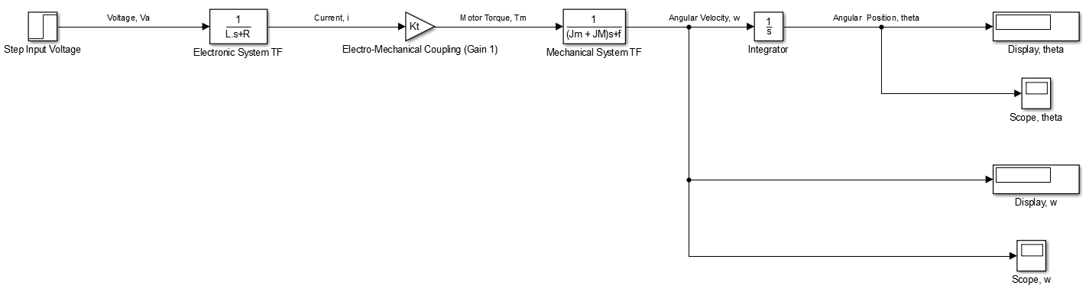

**Fig. 3.4.1(a)**: Simulink Block Diagram

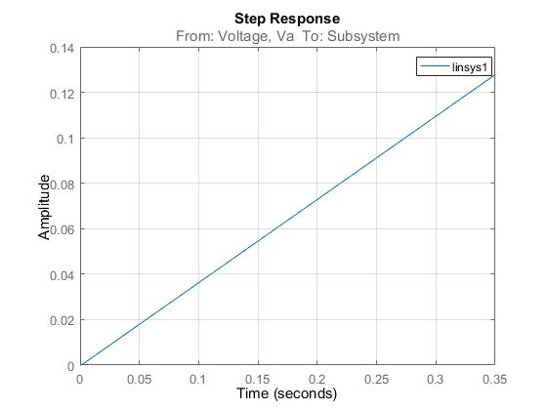

**Fig. 3.4.1(b)**: Angular Position Response to a Step Input

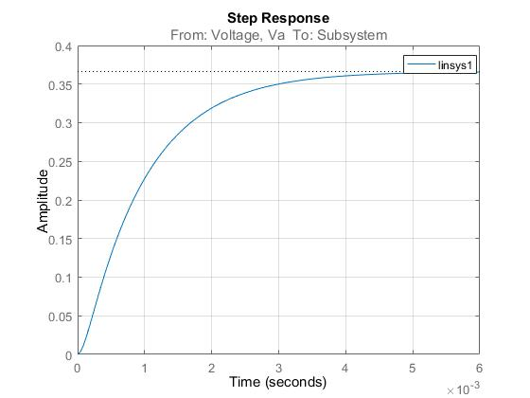

**Fig. 3.4.1(c)**: Angular Velocity Response to a Step Input

(b) ${ For \left[TF\right]}_{{OL}_{2}}:$

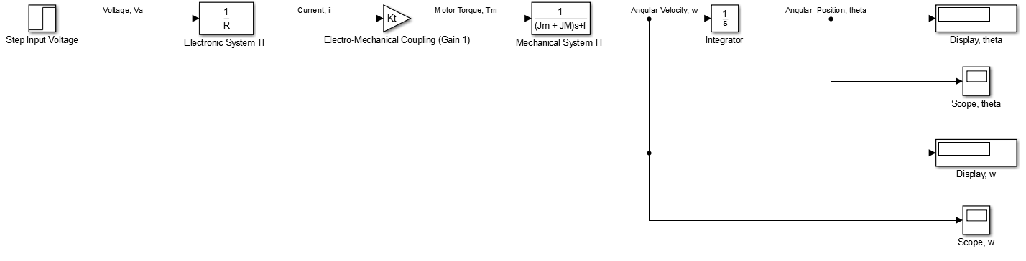

**Fig. 3.4.2(a)**: Simulink Block Diagram

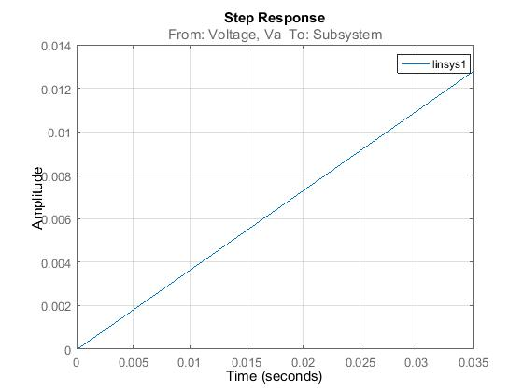

**Fig. 3.4.2(b)**: Angular Position Response to a Step Input

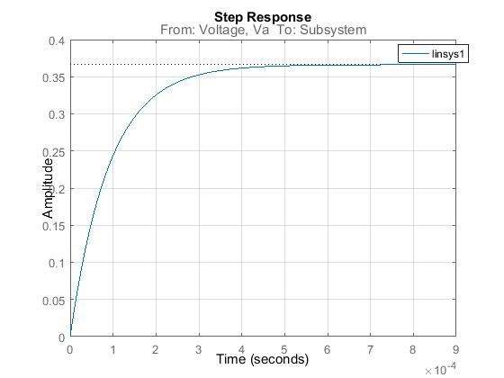

**Fig. 3.4.2(c)**: Angular Velocity Response to a Step Input

As expected, since *La*<< 1, the response for parts (a) and (b) will be approximately the same.

**5.** Using Simulink to get a step response for the close-loop (CL) unit feedback system, adjust the proportional gain if it is necessary.

(a) For Negative Unit Closed-Loop (UCL) Feedback System:

$${[TF]}_{UCL }={\left(\frac{ω\left(s\right)}{V_{a}\left(s\right)}\right)}_{UCL}= \left(\frac{G(s)}{1+H(s)G(s)}\right)$$

$$Such that, H\left(s\right)=K_{e}=1, since K_{e} is the gain associated with the feedback of the loop.$$

$${{\left[TF\right]}_{{UCL}_{1}}= \left\lfloor {\left(\frac{ω\left(s\right)}{V_{a}\left(s\right)}\right)}_{CL}\right\rfloor }_{K_{e}= 1}={\left[\left(\frac{K_{t}}{{{(J}_{m}+ J_{M})L}_{a}s^{2}+\left(L_{a}f+{{(J}_{m}+ J_{M})R}_{a}\right)s+ fR_{a}+K_{t}K_{e}}\right)\right]}_{K_{e} = 1}$$

$${\left[TF\right]}_{{UCL}_{1}}=\left(\frac{K_{t}}{{{(J}_{m}+ J_{M})L}_{a}s^{2}+\left(L_{a}f+{{(J}_{m}+ J_{M})R}_{a}\right)s+ fR_{a}+K_{t}}\right)$$

(b) For reduced (La = 0) Negative Unit Closed-Loop (UCL) Feedback System:

$${\left[TF\right]}_{{UCL}_{2}}= \left(\frac{K_{t}}{{{(J}_{m}+ J_{M})R}_{a}s+ fR_{a}+K_{t}}\right)$$

* For GM9236S013 model used as Motor:

From P.40 in the Lab Manual, the following values for the variables used in the above equations, for the described motor model, can be obtained.

***SPECS (1):***

$$L_{a}=0.66 x {10}^{-3} H$$

$$R_{a}=0.71 Ohms$$

$$J_{m}= 1.0 x {10}^{-3} kgm^{2}$$

$$J_{M}= 1.4 x {10}^{-4} kgm^{2}$$

$$f= 12.5 Nms$$

$$K_{t}= 3.25 Nm/A$$

${For \left[TF\right]}_{{UCL}_{1}}:$

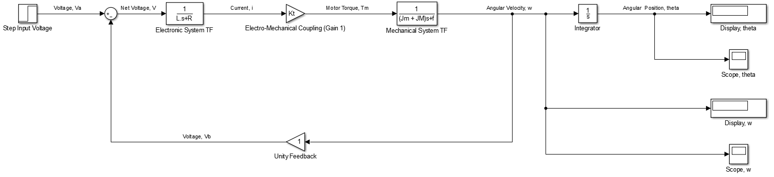

**Fig. 3.5.1(a)**: Simulink Block Diagram

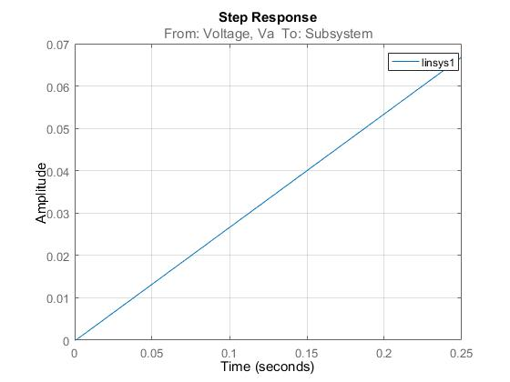

**Fig. 3.5.1(b)**: Angular Position Response to a Step Input

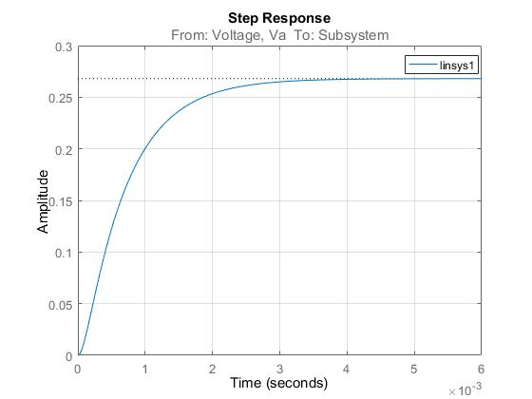

**Fig. 3.5.1(c)**: Angular Velocity Response to a Step Input

(b) ${For \left[TF\right]}_{{UCL}_{2}}:$

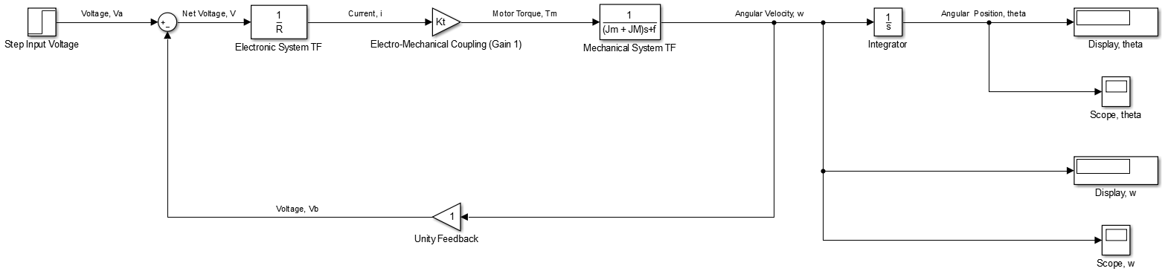

**Fig. 3.5.2(a)**: Simulink Block Diagram

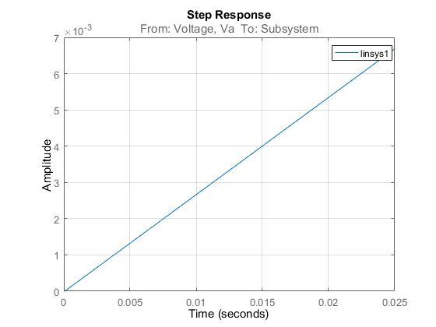

**Fig. 3.5.2(b)**: Angular Position Response to a Step Input

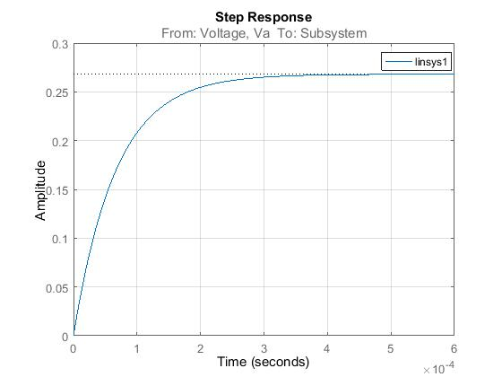

**Fig. 3.5.2(c)**: Angular Velocity Response to a Step Input

As expected, since *La*<< 1, the responses for parts (a) and (b) will be approximately the same.

* **REFERENCES**

[1] W. Xie, H. Hong, T. Wen and G. Huard, *Control System Design MECH 473 Project Manual*. Montreal: Concordia University, 2016, pp. 11-28.

[2] "Calibration of a Linear Motion Potentiometer", *Engr.uidaho.edu*, 2016. [Online]. Available: https://www.engr.uidaho.edu/thompson/courses/ME330/labs/TachometerCalibration.html. [Accessed: 27- Oct- 2016].

[3] *How Rotary Encoder Works and How To Use It with Arduino*. USA: Dejan Nedelkovoski, 2016.

[4] "Amplifiers", *Learnabout-electronics.org*, 2016. [Online]. Available: http://www.learnabout-electronics.org/Amplifiers/amplifiers10.php. [Accessed: 27- Oct- 2016].

[5] "Clemson Vehicular Electronics Laboratory: Brushed DC Motors", *Cvel.clemson.edu*, 2016. [Online]. Available: http://www.cvel.clemson.edu/auto/actuators/motors-dc-brushed.html. [Accessed: 27- Oct- 2016].

[6] G. Huard, T. Wen and H. Hong, *Electronics for Mechanical Engineers*. Montreal: Concordia University, 1999, pp. 9-19.

[7] "Quanser Q4: RCP Data Acquisition Card Support", *Quanser.com*, 2016. [Online]. Available: http://www.quanser.com/products/rcptk/documentation/q4.html. [Accessed: 27- Oct- 2016].